**Report: Lab Work ECS 330 : OP-AMP**

**Date: 19th February 2021**

**Name: Ajay Choudhury**

**Roll No: 18018**

**Title of Experiment 1: Differentiator using OP-Amp**

**Brief Description:**

This OP-AMP amplifier circuit performs the mathematical operation of differentiation, i.e., it produces a voltage output which is directly proportional to the input voltage’s rate of change with respect to time.

In other words, the faster or larger the change to the input voltage signal, the greater the input current, the greater will be the output voltage change in response, becoming more of a spike in shape.

**Schematic diagram and Results:**

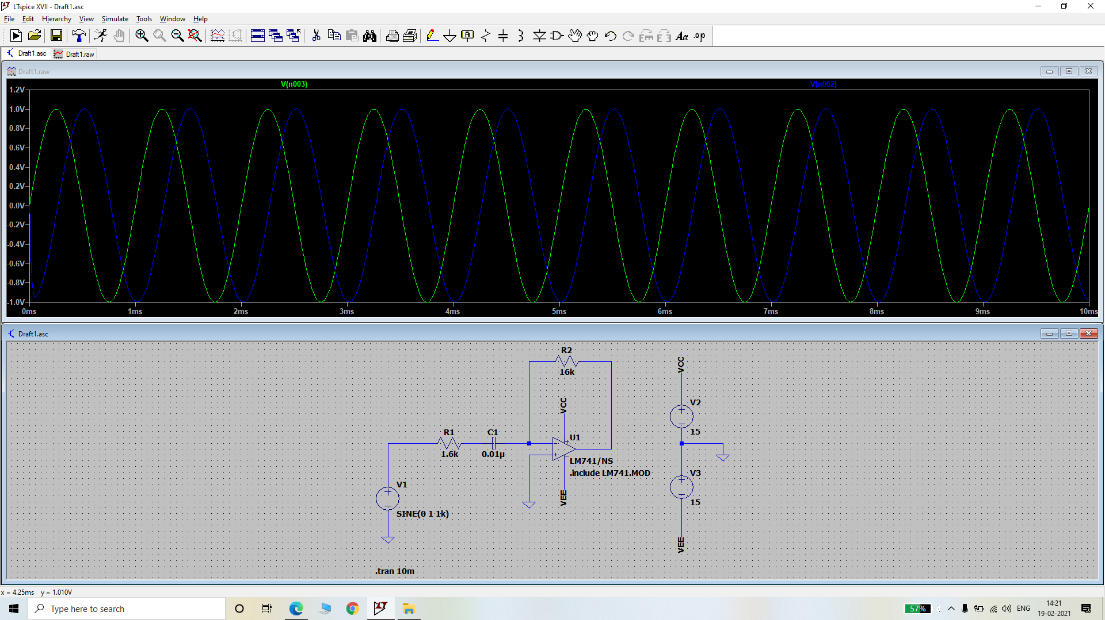

**Fig.: Differentiator circuit with a sine input wave**

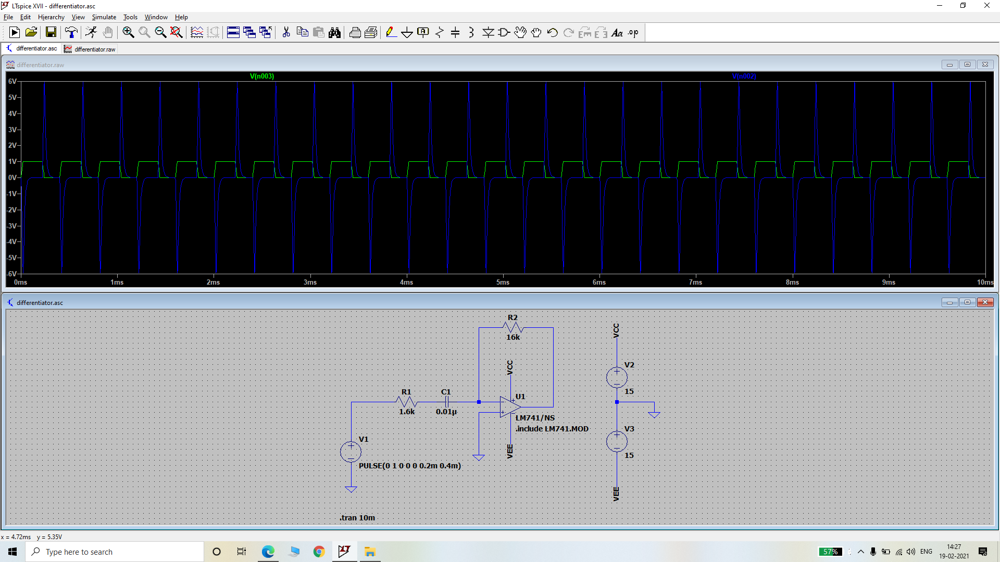

**Fig.: Differentiator circuit with a Square wave as an input signal**

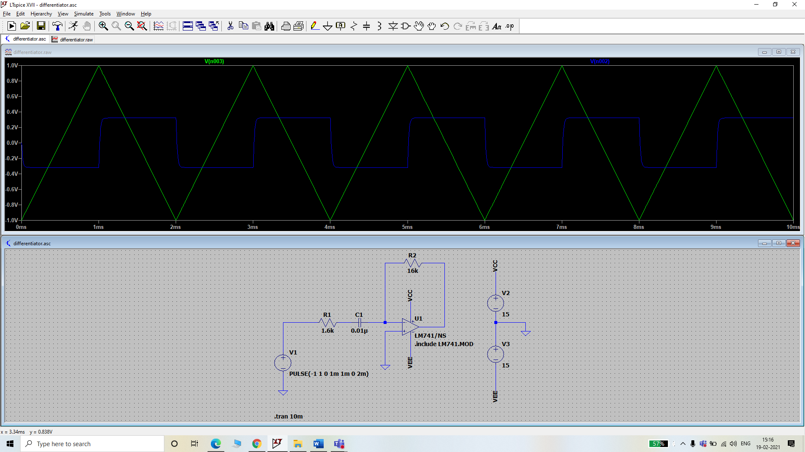

**Fig.: Differentiator circuit with a triangular wave as an input signal**

**Title of Experiment 2: Integrator using OP-Amp**

**Brief Description:**

As its name implies, the OP-AMP Integrator is an operational amplifier circuit that performs the mathematical operation of Integration, that is we can cause the output to respond to changes in the input voltage over time as the OP-AMP integrator produces an output voltage which is proportional to the integral of the input voltage.

**Schematic diagram and Results:**

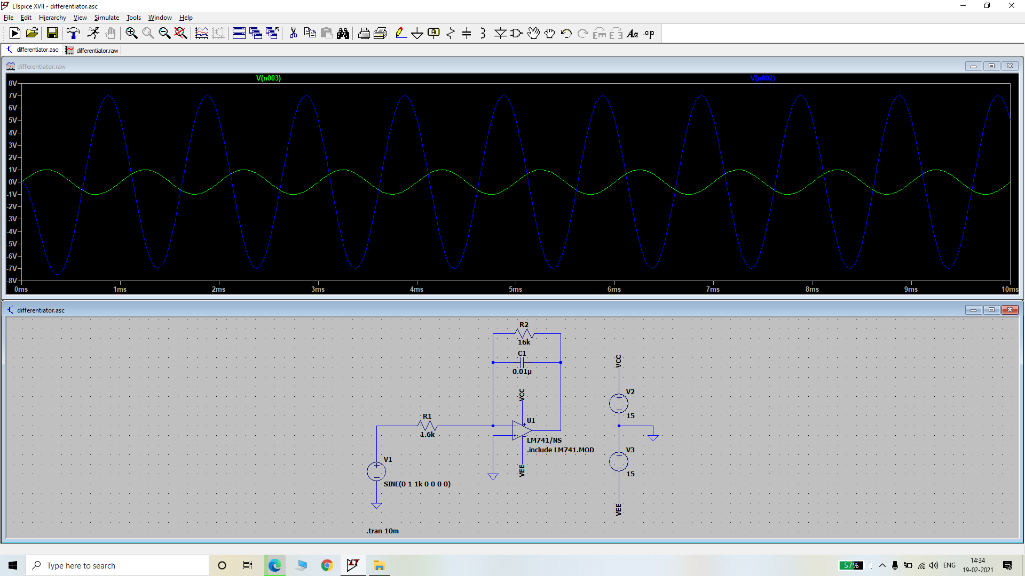

**Fig.: Integrator with sine wave as input signal**

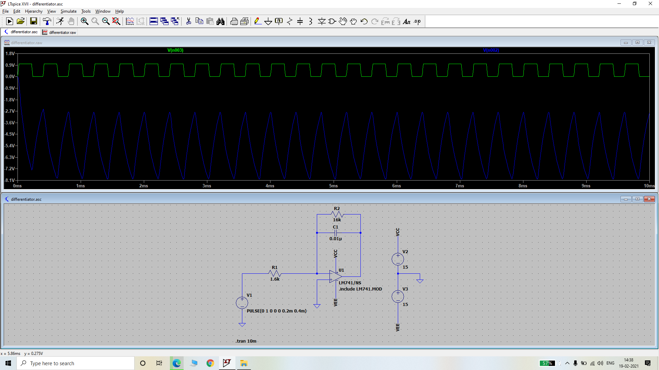

**Fig.: Integrator with Square wave as an input signal**

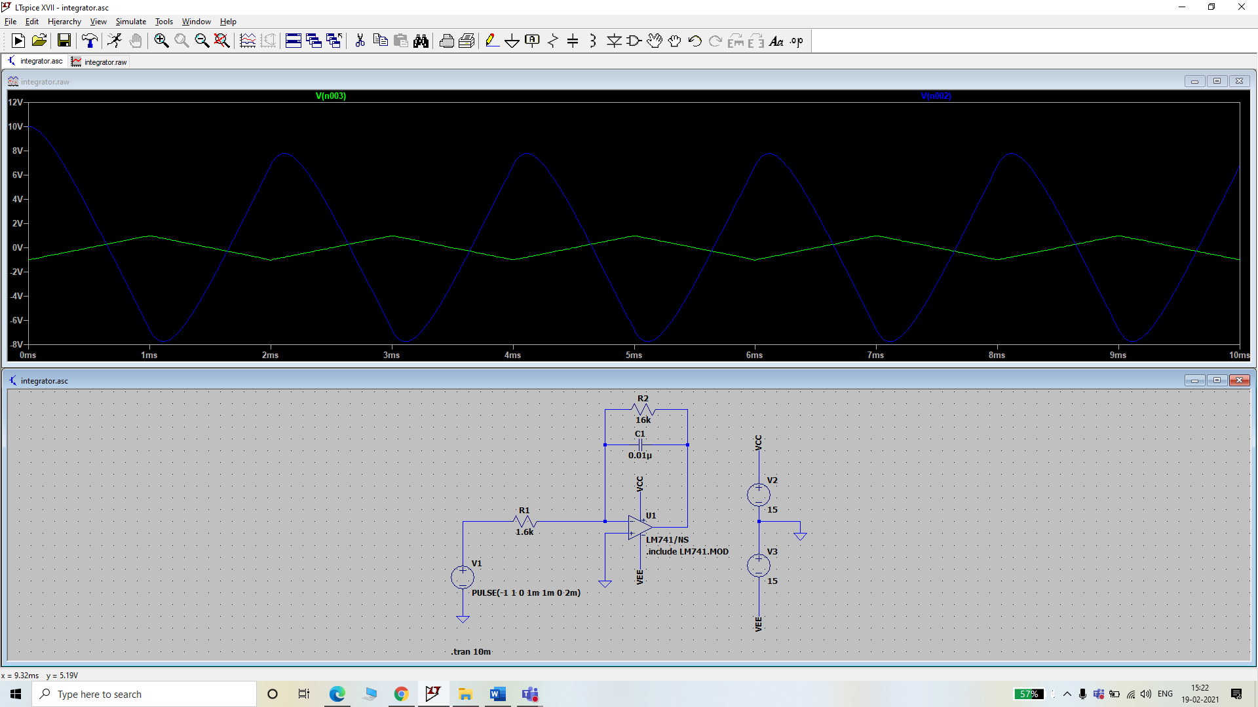

**Fig.: Integrator with Triangular wave as an input signal**

**Title of Experiment 3: Log Circuit using OP-Amp**

**Brief description:**

A logarithmic amplifier, or a log amplifier, is an electronic circuit that produces an output that is proportional to the logarithm of the applied input.

**Schematic diagram and Results:**

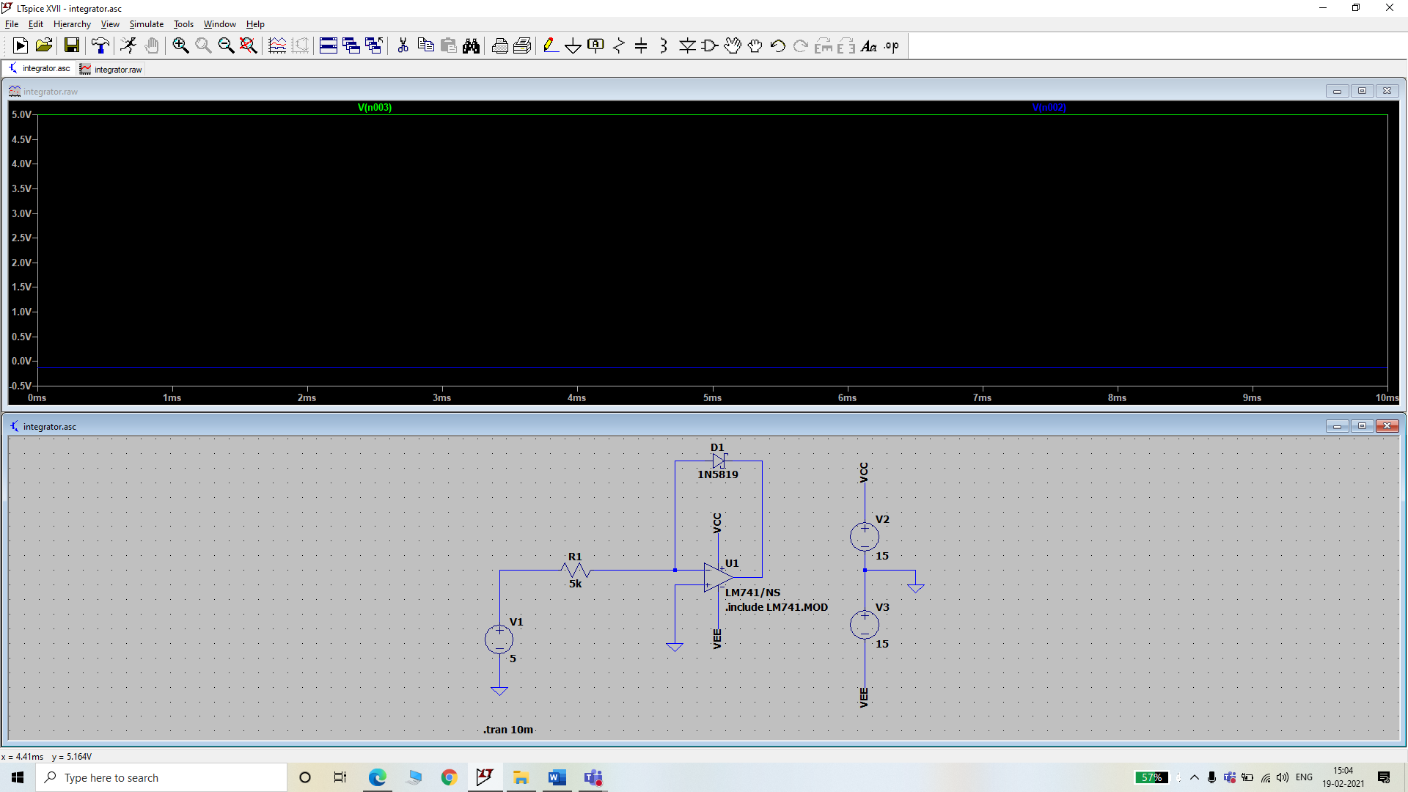

**Fig.: Log Circuit using OP-AMP**

**Title of Experiment 4: Anti-Log Circuit using OP-Amp**

**Brief description:**

An anti-logarithmic amplifier, or an anti-log amplifier, is an electronic circuit that produces an output that is proportional to the anti-logarithm of the applied input.

**Schematic diagram and Results:**

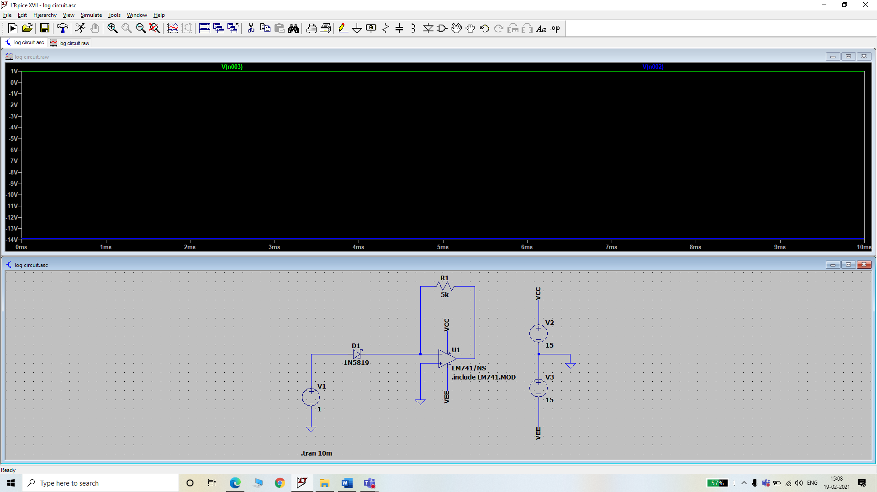

**Fig.: Anti-log Circuit using OP-AMP**